This is a strategic choice. By building this, you are solving a problem that you and your classmates face immediately. It also forces you to handle messy, unstructured text data, which represents a massive portion of real-world ML engineering. Standard tabular datasets (like CSVs of house prices) do not teach you how to parse raw human language.
Here is exactly how to build this system from the ground up.

System Architecture
Before writing code, you need to understand how the data flows from a user's raw PDF upload to a mathematical similarity score.
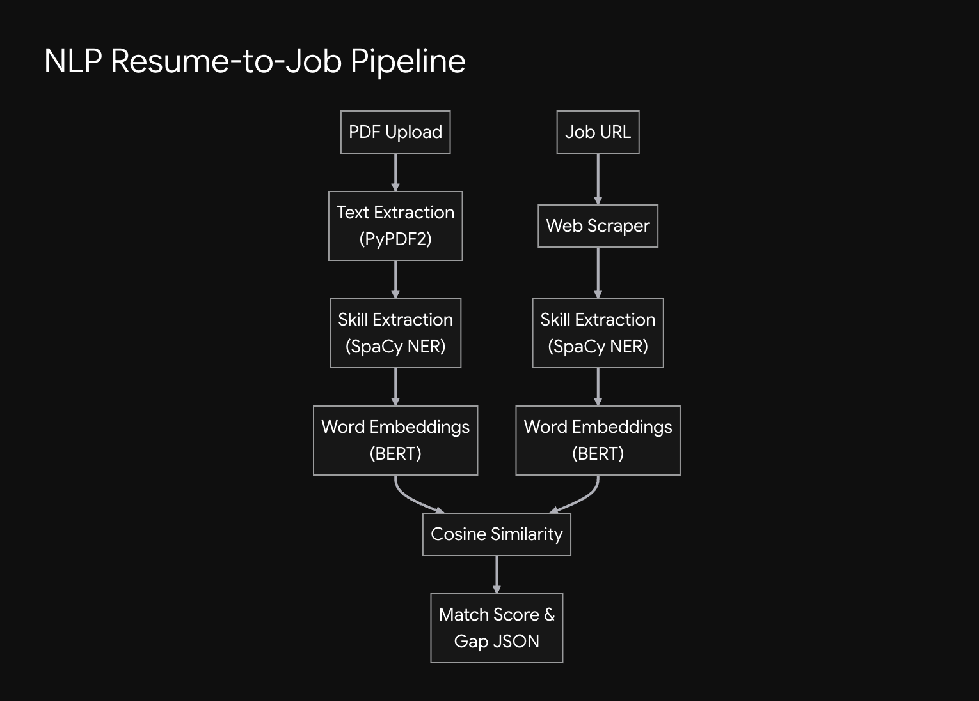
The Core Mechanism: The system does not just look for exact keyword matches. It converts the text of the resume and the job description into high-dimensional vectors (arrays of numbers). It then calculates the angle between these two vectors using Cosine Similarity:
$$\text{similarity}=\cos\left(θ\right)=\frac{A⋅B}{\left\|A\right\|\left\|B\right\|}$$
If the vectors point in the same direction, the similarity is close to 1 (a strong match).

Development Roadmap (2.5 Weeks)
1.Literature Review & Setup:Days 1-2.
Set up your virtual environment and install dependencies (spacy, transformers, scikit-learn, fastapi, PyPDF2). Read up on Named Entity Recognition (NER) and how BERT generates contextual embeddings.
2.Data Collection & Parsing:Days 3-5.
Download the Kaggle Resume Dataset. Write a Python script using PyPDF2 or pdfplumber to extract raw text from PDF files. Write a secondary script to scrape 50-100 job descriptions from Indeed or LinkedIn using BeautifulSoup.
3.NLP Entity Extraction:Days 6-9.
Use Spacy to process the extracted text. You will likely need to create a custom Entity Ruler in Spacy to explicitly tag tech skills (e.g., "Python", "AWS", "TensorFlow"), as default Spacy models are trained on general news text, not developer resumes.
4.Embedding & Similarity Engine:Days 10-12.
Pass the extracted skills through a pre-trained sentence transformer (like all-MiniLM-L6-v2 from Hugging Face). Calculate the cosine similarity between the resume vector and the job description vector.
5.Skill Gap Logic:Days 13-14.
Write the logic to perform a set difference. Compare the extracted entities from the job description against the entities from the resume to generate a list of "Missing Skills".
6.API Deployment:Days 15-17.
Wrap the entire pipeline in a FastAPI application. Create a /match endpoint that accepts a PDF file and a text string (job description) and returns a JSON payload containing the match percentage and the missing skills array.

GitHub Repository Structure
Keep your project organized. A clean structure proves to recruiters that you understand software engineering, not just Jupyter notebooks.
- app/
  - main.py (FastAPI routing)
  - ml_pipeline.py (Spacy and BERT loading)
  - utils.py (PDF extraction and text cleaning)
- notebooks/
  - 01_data_exploration.ipynb
  - 02_spacy_custom_ner.ipynb
- data/ (Add this to .gitignore)
- requirements.txt
- README.md

Viva & Presentation Guide

How to Present
Do not show raw code during your presentation. Build a simple frontend (even a basic Streamlit app) where you can upload your own resume and paste a real job description from a company your classmates recognize. Seeing the app identify that you are missing "Docker" for a specific role makes the concept instantly click.

Likely Viva Questions
Question | How to Answer
Why not just use keyword matching? | Explain that keyword matching fails on synonyms. If the job asks for "Machine Learning" and the resume says "ML", keyword matching fails. Vector embeddings capture the semantic meaning.
How did you handle the cold start problem for specific tech skills? | Discuss creating a custom Spacy Entity Ruler list containing common tech stack keywords to ensure they aren't missed by the pre-trained model.
Why did you use Cosine Similarity instead of Euclidean Distance? | Euclidean distance is affected by the length of the text. A very long resume and a short job description might have a large distance even if they discuss the same topics. Cosine similarity only measures the angle (direction), making it robust to document length.

Future Scope (Productization)
To make this look like a real product rather than a lab assignment, implement a Course Recommender. Once your pipeline identifies the "Missing Skills" (e.g., "Missing: Kubernetes"), query a database (or a mocked JSON file) of Coursera/Udemy links to automatically recommend a course to bridge that specific gap.

